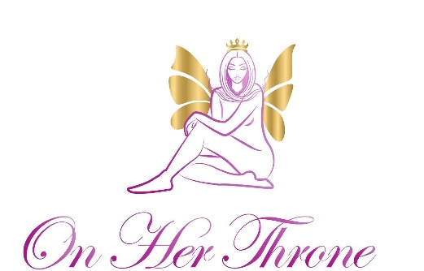

Thank you for your Business! Have inquires for your business?

Rebranding-
On Her Throne services yoni businesses looking to rebrand products.
Products for rebranding:
-All Yoni steams and custom blends
-Yoni oil
-Herbal teas
-Bath soaks
- Yoni soap
-Yoni powder
-Facial serum
For all other products and inquiries please contact us via email.

Rebranding for yoni steam:
Only available for wholesale of 50 steams or more- rebranding Pricing- is an extra 15% charge on top of the regular price. Ex: 50 steams cost $100 plus 15 % total cost: $115

Rebranding guidelines:
Contact On Her Throne with all rebranding business inquiries.
Must submit Yoni steaming practitioner certification via email prior to placing order.
Yoni steam ingredients may not be shared or sold.
Blends can only be rebranded and sold under On Her Throne products that you have permission to do so. You may not use the exact same ingredients to make your own blend as this is a form of trademark infringement. On her throne signature blends are legally copy righted and trademarked.
Thank you for your time and business!
Please sign here as an acknowledgement of our policies regarding our ingredients and rebranding guidelines. X Date:
Contact us via email at onherthroneholisticspa@gmail.com
Follow us on IG: onherthrone_holistic
Website: www.onherthroneholisticspa.com

